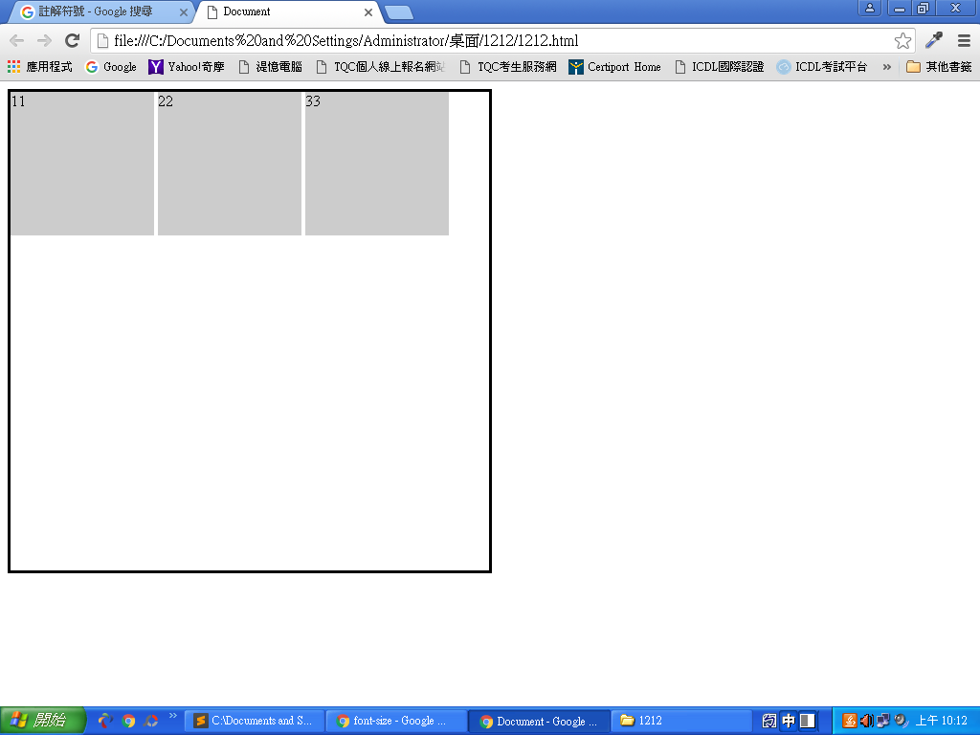

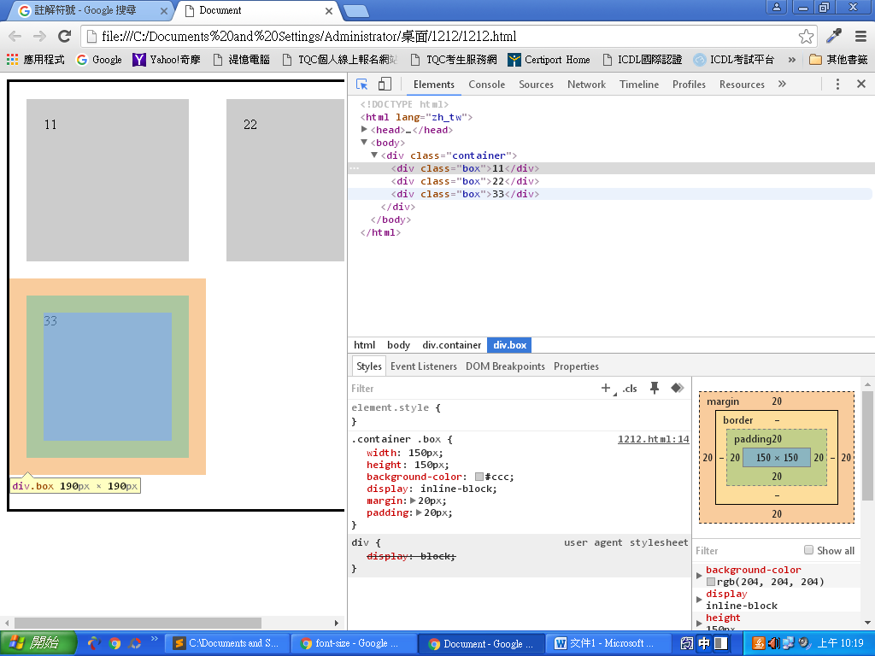

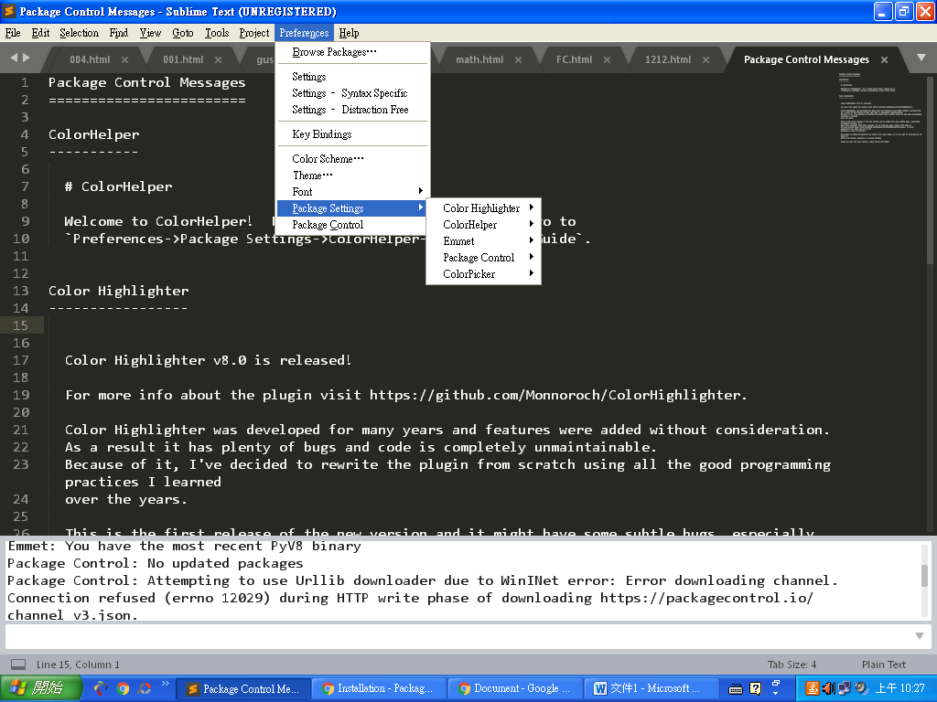

<!DOCTYPE html>

<html>

<head>

<meta charset="UTF-8">

<title>Document</title>

<style>

.container{

width: 300px;

height: 300px;

border: 3px solid #000;

}

.container .box{

width: 50px;

height: 50px;

}

.container .box:nth-of-type(1){

background-color: #996;

}.container .box:nth-of-type(2){

background-color: #DB2;

}.container .box:nth-of-type(3){

background-color:#F4E10A;

}

.container1{

position: relative;

}

.container1 .box{

position:absolute;

top:0;

bottom: 0;

left: 0;

right: 0;

margin: auto;

}

.container .box:nth-of-type(2){

background-color: #DB2;

}

.container2 .box{

line-height: 300px;

}

.container3{

position: relative;

}

.container3 .box{

position: absolute;

top: 50%;

left: 50%;

transform:translate(-50%,-50%);

}

.container4{

display: table-cell;

text-align: center;

vertical-align: middle;

font-size: 0;

}

.container4 .box{

display: inline-block;

font-size: 16px;

}

</style>

</head>

<body>

<div class="container container1">

<div class="box"></div>

<div class="box"></div>

<div class="box"></div>

</div>

<div class="container container2">

<div class="box">11</div>

<div class="box">22</div>

<div class="box">33</div>

</div>

<div class="container container3">

<div class="box"></div>

<div class="box"></div>

<div class="box"></div>

</div>

<div class="container container4">

<div class="box"></div>

<div class="box"></div>

<div class="box"></div>

</div>

<div class="container container5">

<div class="box"></div>

<div class="box"></div>

<div class="box"></div>

</div>

</body>

</html>

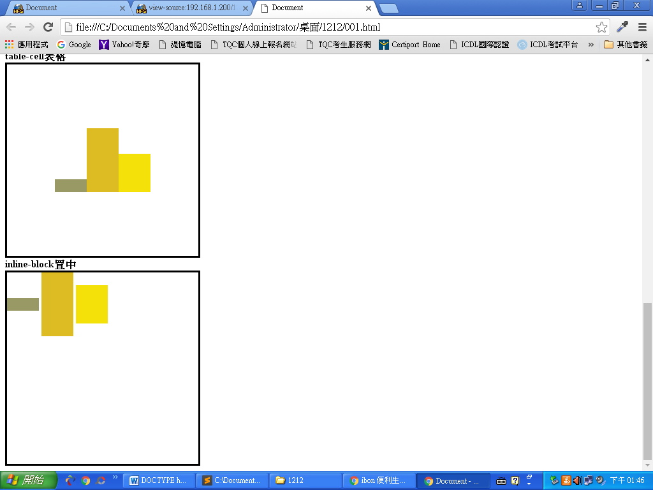

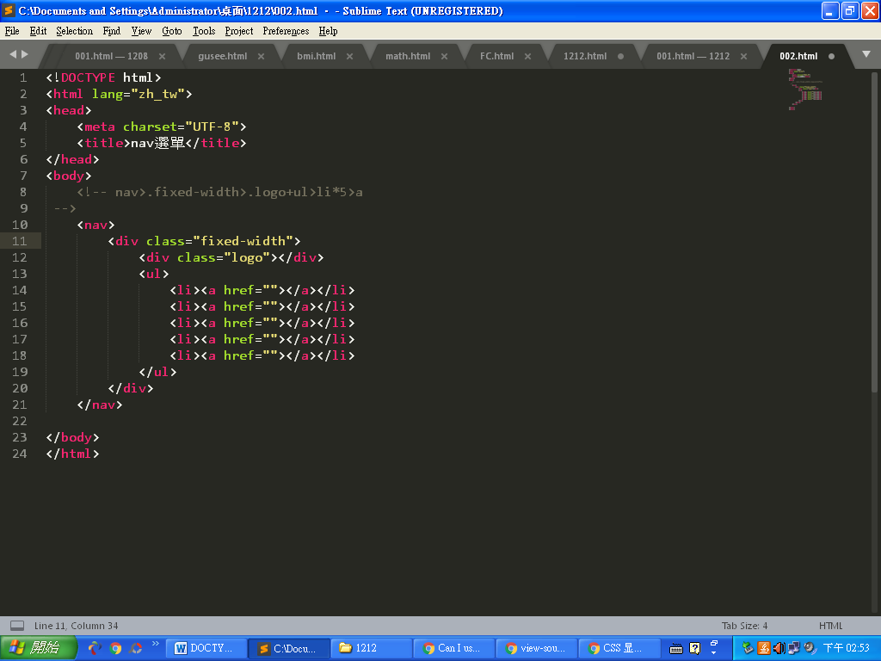

<!DOCTYPE html>

<html lang="zh_tw">

<head>

<meta charset="UTF-8">

<title>nav選單</title>

<style>

*{font-family: "微軟正黑體";

}

body,h1,h2{

margin:0;

padding: 0;

}

.clearfix::after{

content: "";

display: block;

clear: both;

}

nav{

width: 100%;

background-color: #262626;

}

</style>**(圖一)**

</head>

<body>

<!-- nav>.fixed-width>.logo+ul>li*5>a -->

<!-- nav>.fixed-width>.logo+ul>li*5>a{memue$} -->

<nav>

<div class="fixed-width">

<div class="logo"></div>

<ul>

<li><a href="">menue</a></li>

<li><a href="">menue</a></li>

<li><a href="">menue</a></li>

<li><a href="">menue</a></li>

menue<li><a href="">menue</a></li>

</ul>

</div>

</nav>

</body>

</html>

**(圖一)**

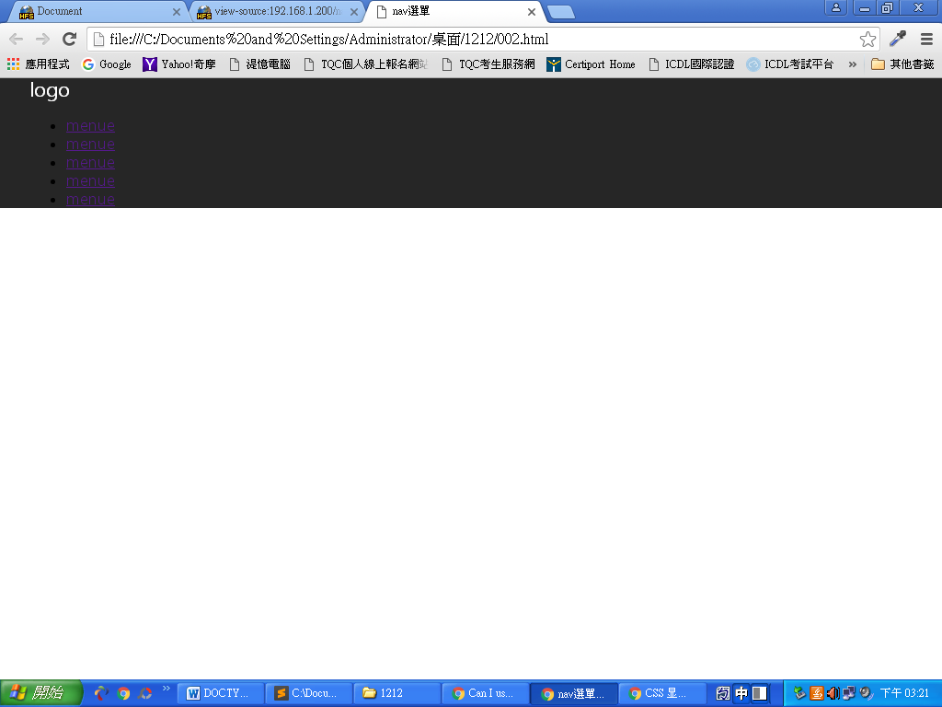

nav{

width: 100%;

background-color: #262626;

}

(接下來)

.fixed-width{

width: 960px;

margin: auto;

}

nav .logo{

font-size: 20px;

color: #fff;

height: 70px;

float: left;

line-height: 70px;

}

nav ul{

float: right;

}

nav li{

list-style-type: none;

float: left;

}

</style>

**(圖二)**

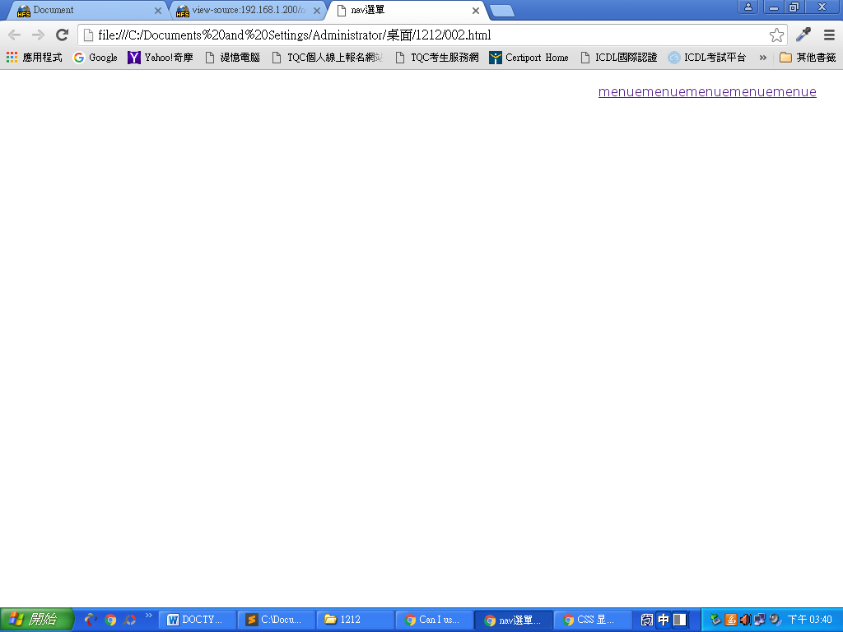

<body>

<!-- nav>.fixed-width>.logo+ul>li*5>a -->

<!-- nav>.fixed-width>.logo+ul>li*5>a{memue$} -->

<nav>(圖二)

<div class="fixed-width">

<div class="logo"></div>

<ul>

<li><a href="">menue</a></li>

<li><a href="">menue</a></li>

<li><a href="">menue</a></li>

<li><a href="">menue</a></li>

menue<li><a href="">menue</a></li>

</ul>

</div>

</nav>

</body>

</html>

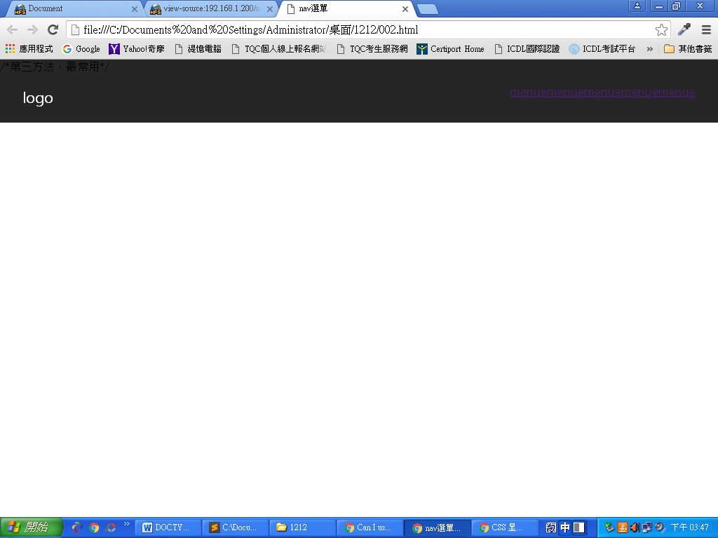

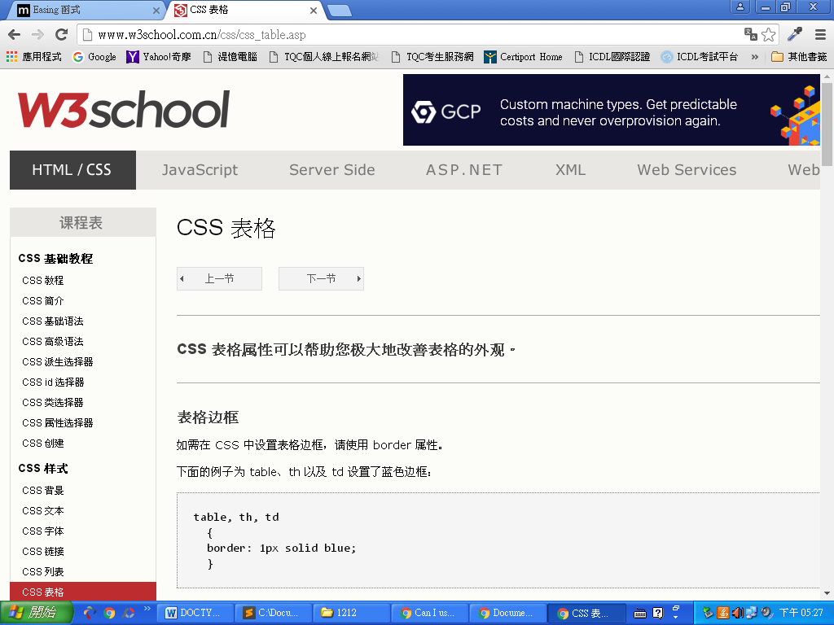

<http://www.w3school.com.cn/css/css_table.asp>

2017/12/13 設計一個網頁

|  |  |
| --- | --- |
| <!DOCTYPE html>  <html lang="en">  <head>  <meta charset="UTF-8">  <title>Document</title>  <style>  @import url('https://fonts.googleapis.com/css?family=Roboto:400,700');  @import url(https://fonts.googleapis.com/earlyaccess/notosanstc.css);  *{  font-family: roboto,"Noto Sans TC";  }  body,h1,h2,h3,h4,h5,h6{  margin: 0;  padding: 0;  }  .clearfix::after{  content: "";  display: block;  clear: both;  }  a{  text-decoration: none;  color:#000;  }  img{  width: 100%;  }  .fixed-width{  width: 960px;  margin:auto;  }  .full-width{  width: 100%;  } | 中文字形google font early acess  英文字型google fonts |
| 這些語法可以由Rest CSS |
| .col-2{ width: calc(50%-30px);  margin  float:left;  margin: 0 15px;  } 該section有兩個區塊  .col-3{  width: calc(100%/3-30px);  float:left;  margin: 0 15px;  自動計算寬  } 有三個區塊  .col-4{  width: calc(100%/4-30px);  float:left;  margin: 0 15px;  } 有四個區塊 |  |
| <body>  <!-- nav.full-width>.fixed-width>.logo+ul>li*8>a -->  <nav class="full-widty"> (全部)  <div class="fix-width">  <div class="logo"></div>  同一層  <ul>  <li><a href=""></a></li>  <li><a href=""></a></li>  <li><a href=""></a></li>  <li><a href=""></a></li>  <li><a href=""></a></li>  下一層  <li><a href=""></a></li>  <li><a href=""></a></li>  <li><a href=""></a></li>  </ul>  </div>  </nav> |  |
|  |
| .col-4{  width: calc(100%/4-30px);  float:left;  margin: 0 15px;  }  <承上>  nav{  background-color:#272824;  }  nav .logo{  float: left;  height: 70px;(此時的logo寬高很貼字)  line-height: 70px;  color: #fff;  font-size: 22px;  border: 1px solid #fff;  }  nav .orang{  color: #fbee04;  }  nav ul{  float:right;  }  nav li{  list-style-type: none;  float: left;  }  nav a{  display:block;  height: 70px;  line-height: 70px;  color: #fff;  text-align: center;  padding-left: 15px;  }  </style>  </head>  <body>  <!-- nav.full-width>.fixed-width>.logo+ul>li*8>a -->  <nav class="full-widty clearfix"> (沒clearfix fix-width會不見  <div class="fix-width">  <div class="logo">FEATURE<span class="orang">D</span></div> (logo最後一個字橘色)  <ul>  <li><a href="">Home</a></li>  <li><a href="">Service</a></li>  <li><a href="">About Us</a></li>  <li><a href="">Team</a></li>  <li><a href="">Store</a></li>  <li><a href="">Testimonial</a></li>  <li><a href="">News</a></li>  <li><a href="">Contact</a></li>  </ul>  </div>  </nav>      </body>  </html> |  |
| nav .logo{  float: left;  height: 40px;(變高)  line-height: 40px;(置中)  color: #fff;  font-size: 22px;  border: 3px solid #fff;  font-weight: 600;(變粗字)  margin:12px 0;  padding:0 5px;(使橫變寬) | 調整logo大小始字置中，  Height-margin-border=70-24-6=40  原來height:70 |
| </nav>  <header class="full-width"></header> | 放圖片，到visual hunt找圖，另存檔案 |
| header{  background-image: url(hodling-present-hand.jpg);  background-repeat: no-repeat;  -webkit-background-size:cover;  background-size: cover;  padding: 280px 0;  }  </style> |  |
|  | 圖片往上跑 |
|  | Fix width變透明 |
|  | Header之padding拉高 |
|  |  |

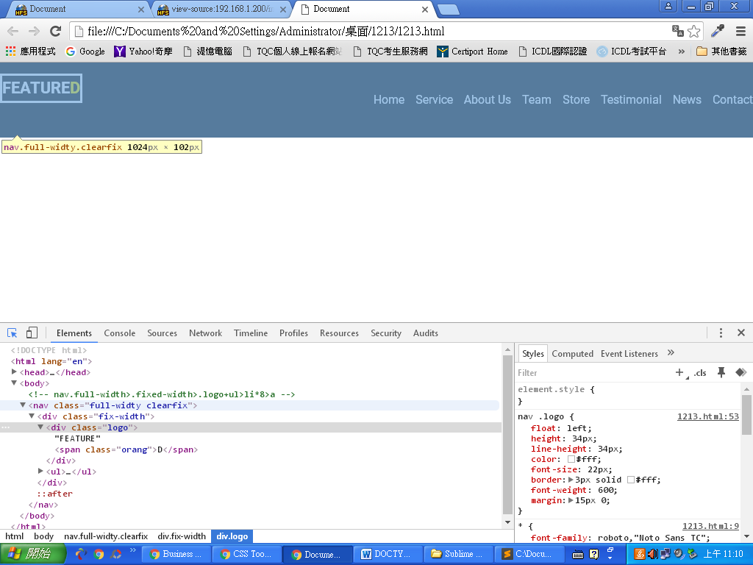

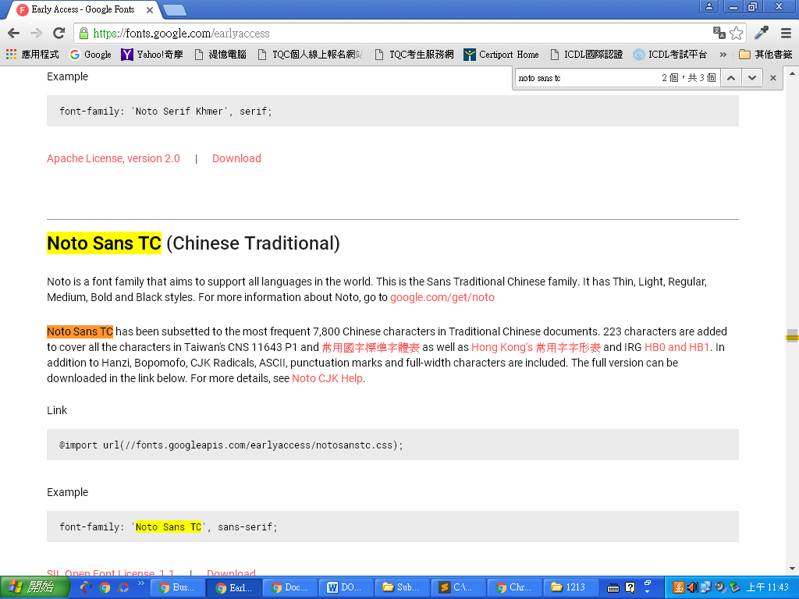

</nav>

<header class="full-width">

<div class="title">

<h1>Beautiful WordPress Business Theme</h1>

<hr>

<h3>Cleanly Coded With User Friendly Interface</h3>

</div>

</header>

</body>

</html>

header .title{

text-align: center;

}

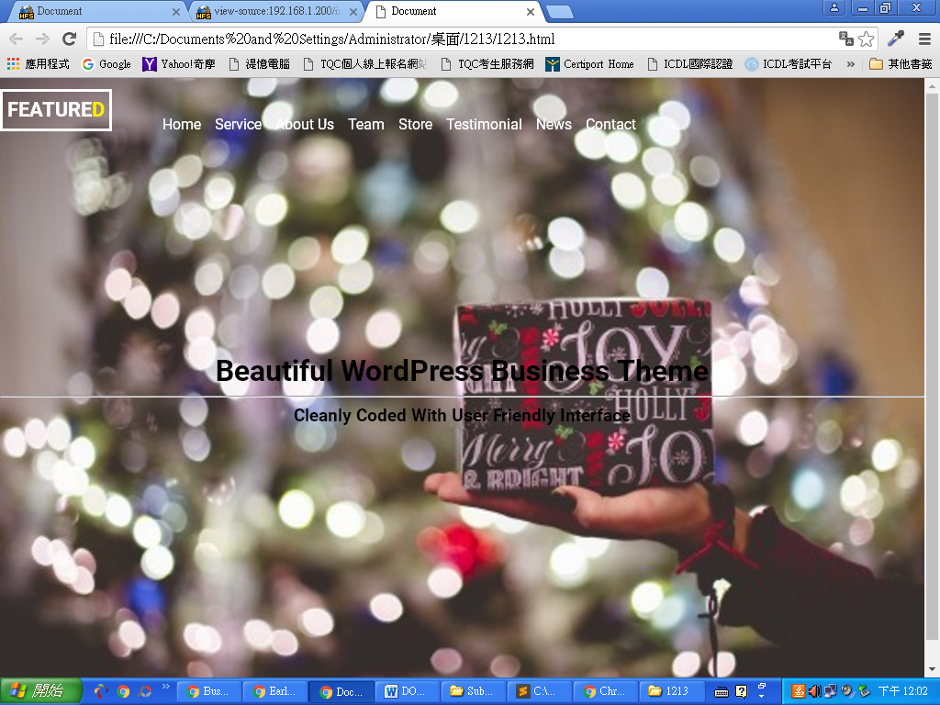

header .title h1{

font-size: 36px;

color:#fff;

}

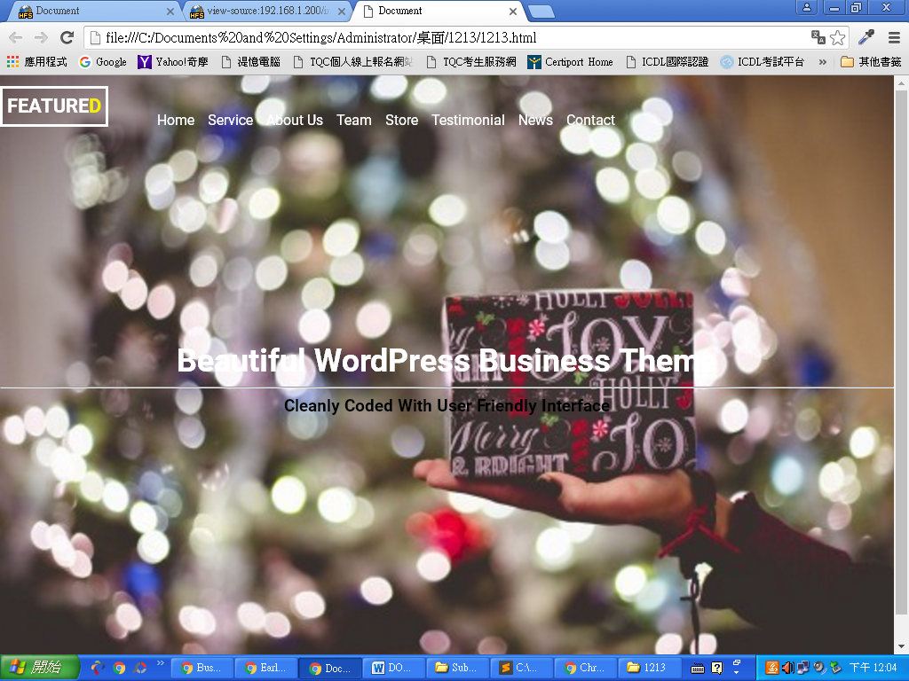

header .title hr{

width: 270px;

height:1px;

background-color: #fff;

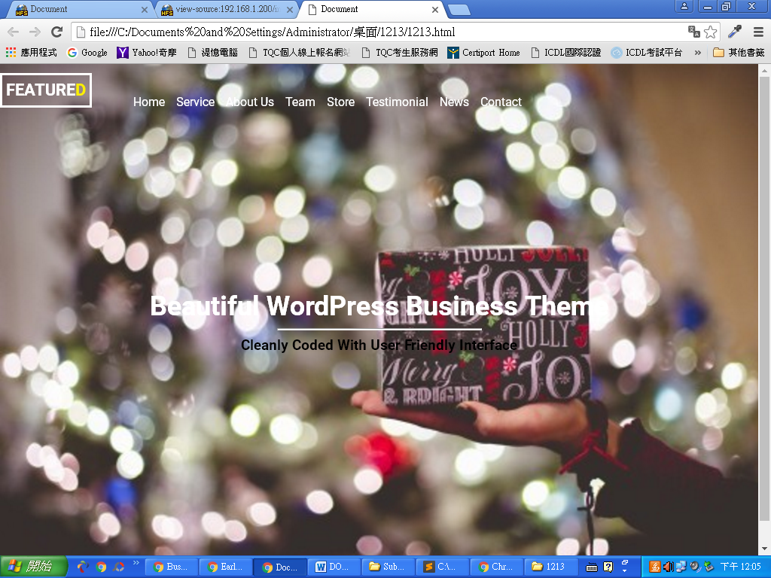

header .title h3{

color: #fff;

font-style: italic;

font-size: 24px;

}

</style>

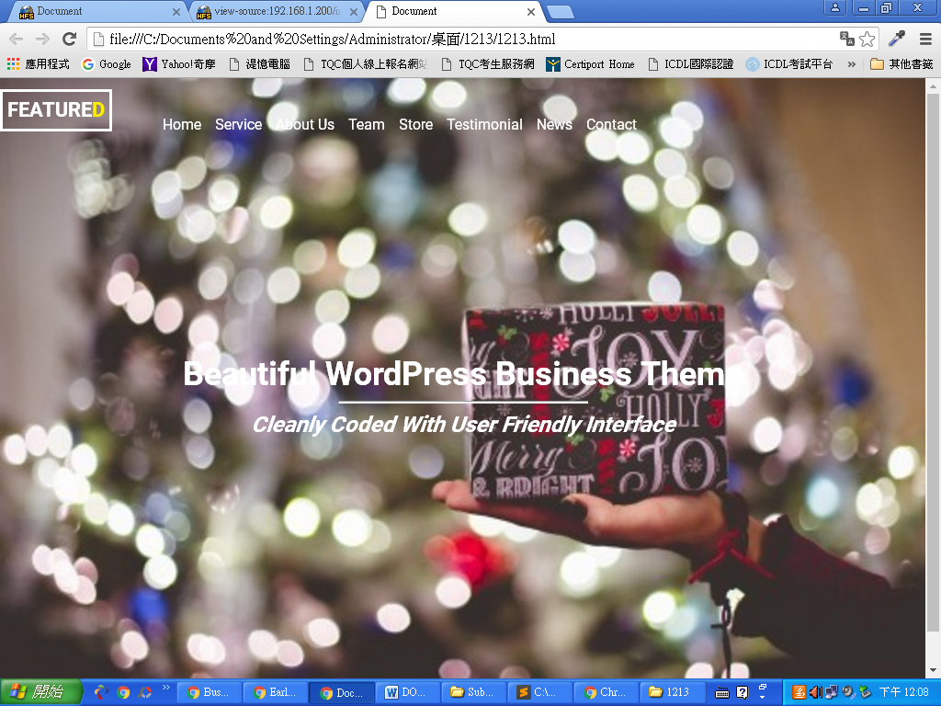

|  |  |
| --- | --- |
| <<a href="">Buy Now</a>  </div>  </header>    </body> |  |
| 模仿別人按鈕的高寬 |  |
| header .title a{  display: block;  width: 86px;  height: 25px;  text-align: center;  line-height: 25px; |  |
| 承上  background-color: rgba(255,255,255,.5);  padding: 10px 20px;  margin: auto;  margin-top: 50px;  border-radius: 5px;  }  </style> |  |

|  |  |
| --- | --- |
|  | 該section有三塊 |
|  |  |
|  |  |
|  |  |
|  |  |
|  |  |
|  |  |
|  |  |

|  |  |
| --- | --- |
|  |  |
| <div class="menu"><div class="col-3">  <div class="icone fa fa-hand-peace-o fa-2x"></div>  <h4>Parallax Effect</h4>  <p>Lorem ipsum dolor sit amet, consectetur . </p>  </div>  <div class="col-3">  <div class="icone fa fa-bicycle fa-2x"></div>  <h4>Unlimited Options</h4>  <p>Lorem ipsum dolor sit amet, consectetur. </p>  </div>  <div class="col-3">  <div class="icone fa fa-heart fa-2x"></div>  <h4>Responsice Design</h4>  <p>Lorem ipsum dolor sit amet, consectetur. </p>  </div>  </div>  </header>  </body>  </html> | 三塊字變白    Icone |
|  | Example |

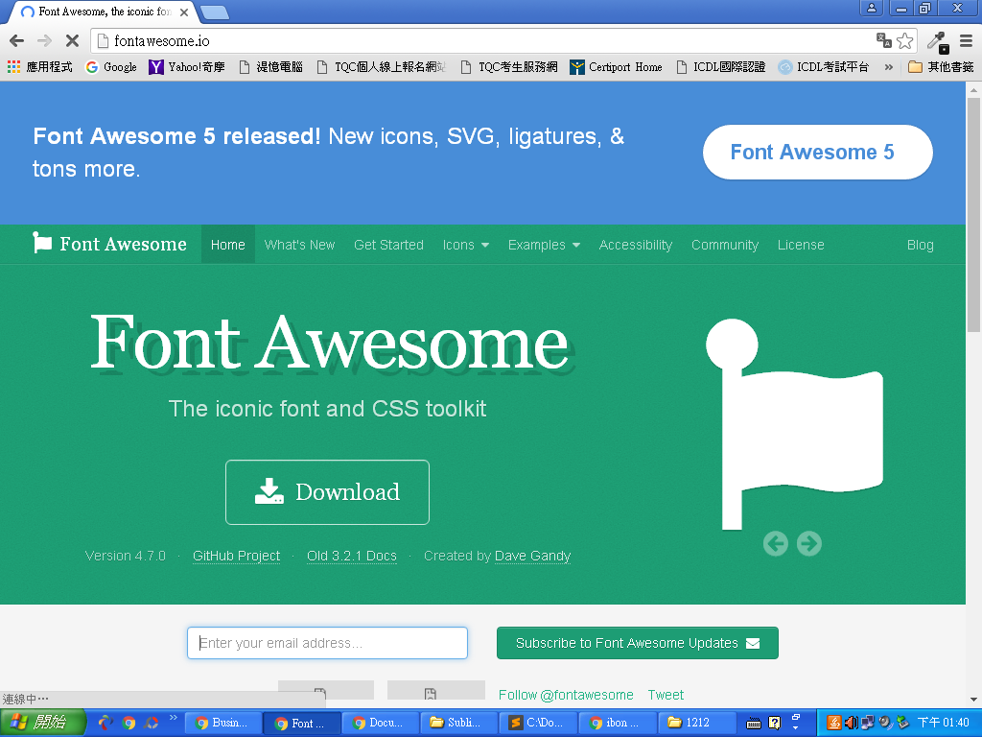

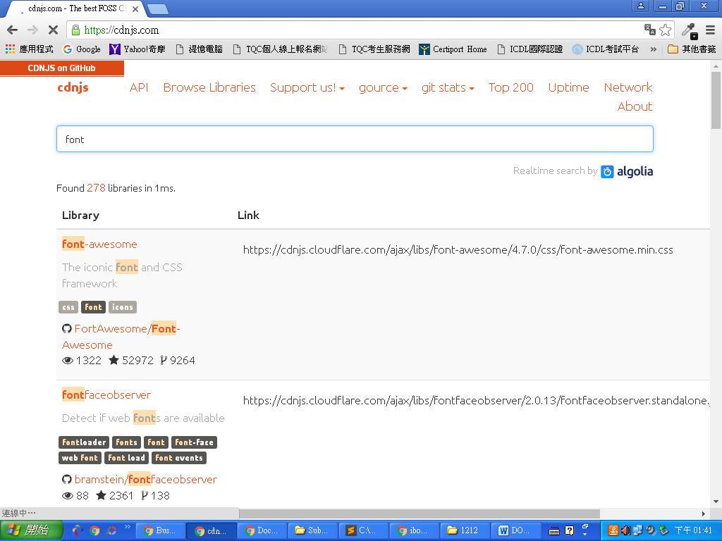

Icone移中間，Icone調距離，Icone不要貼buynow

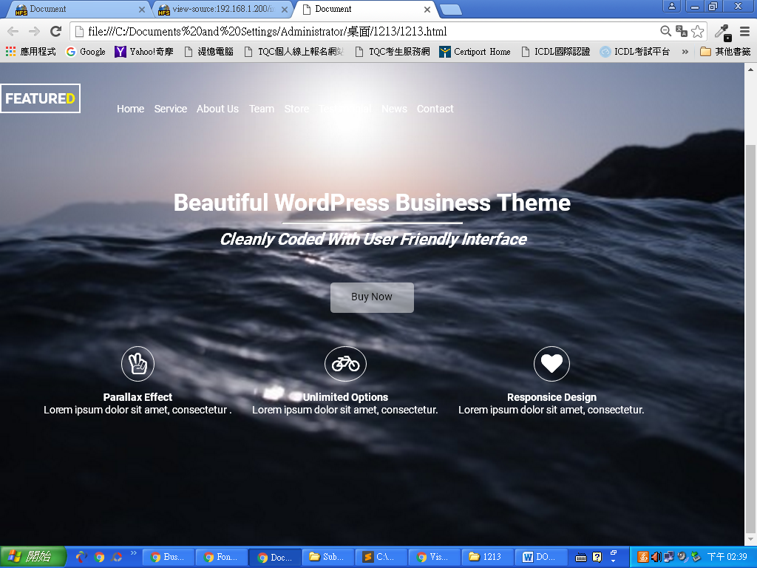

header .menu .col-3{

transition:all 0.3s;

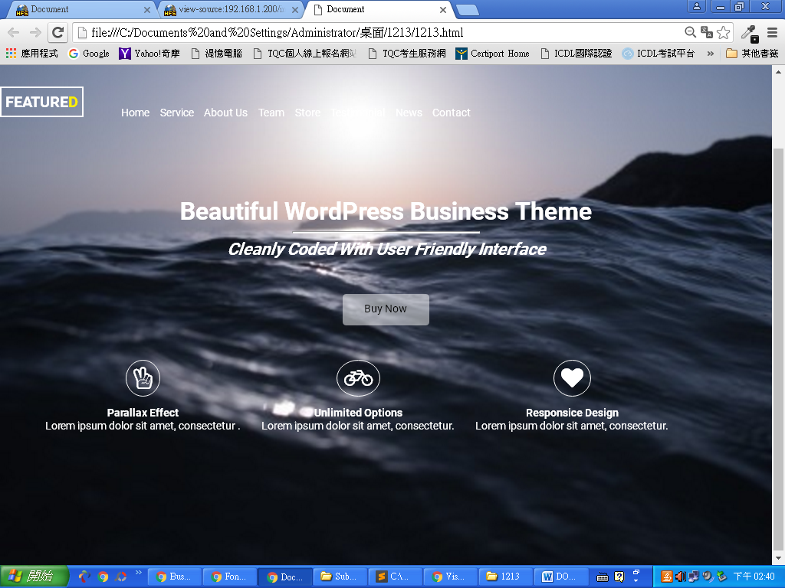

header .menu .col-3{

transition:all 0.3s;

padding: 15px;

-webkit-box-sizing: border-box;

-moz-box-sizing: border-box;

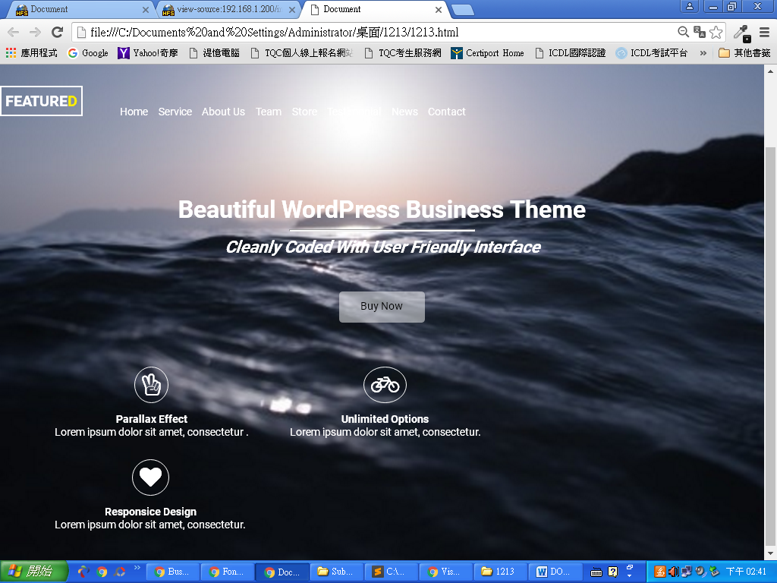

因設定相對定位與絕對定位，

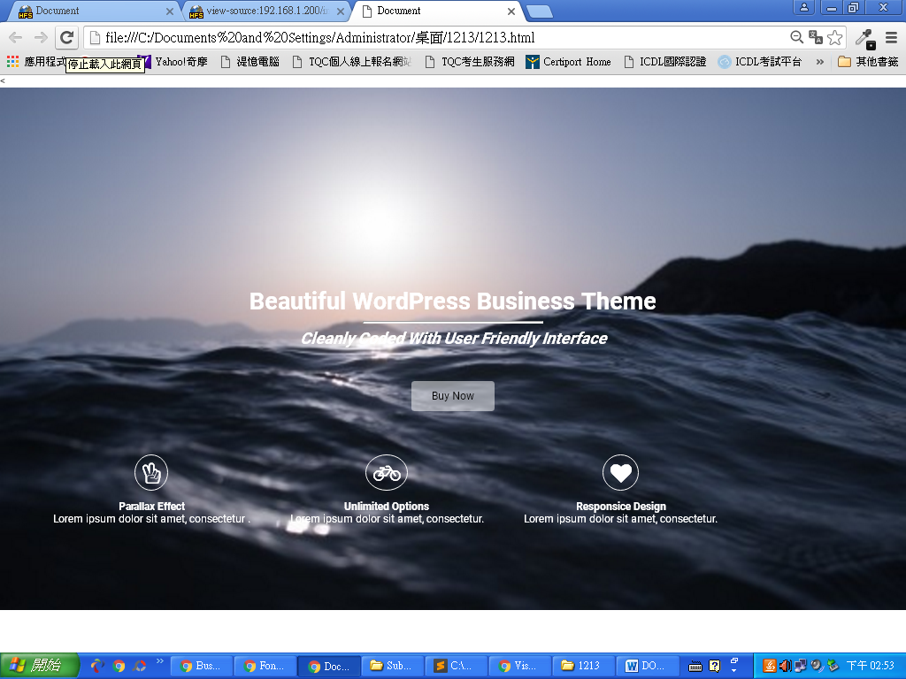

nav{

background-color:transparent;

position: fixed;

z-index: 9;(設任何數字皆可)

}

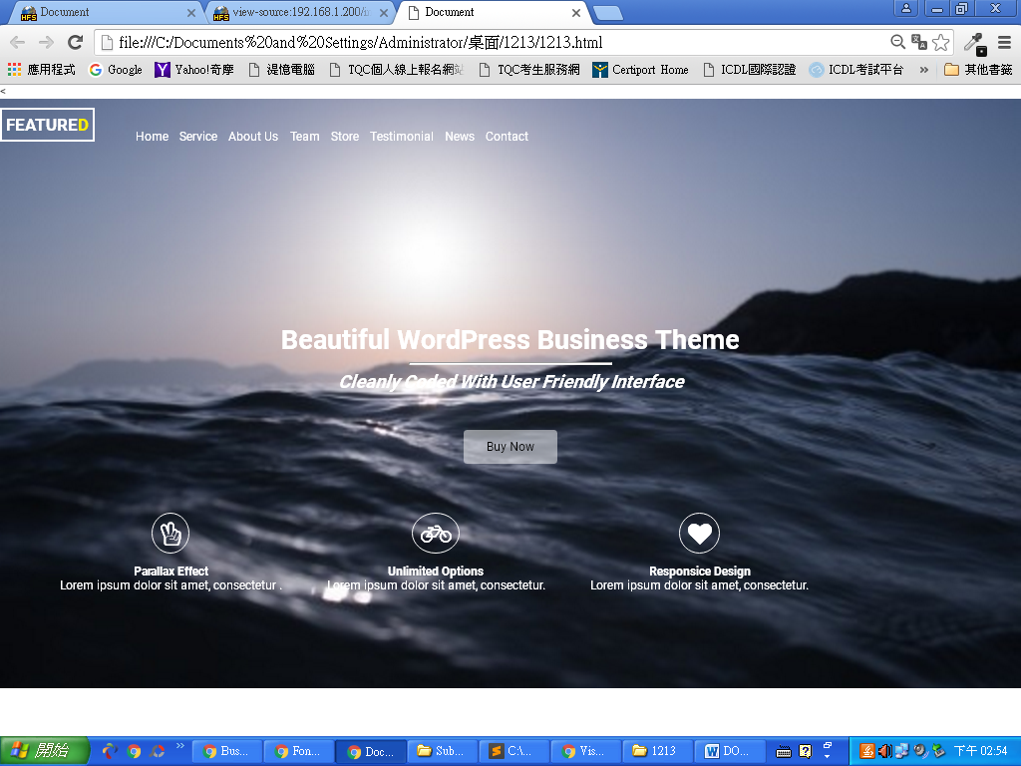

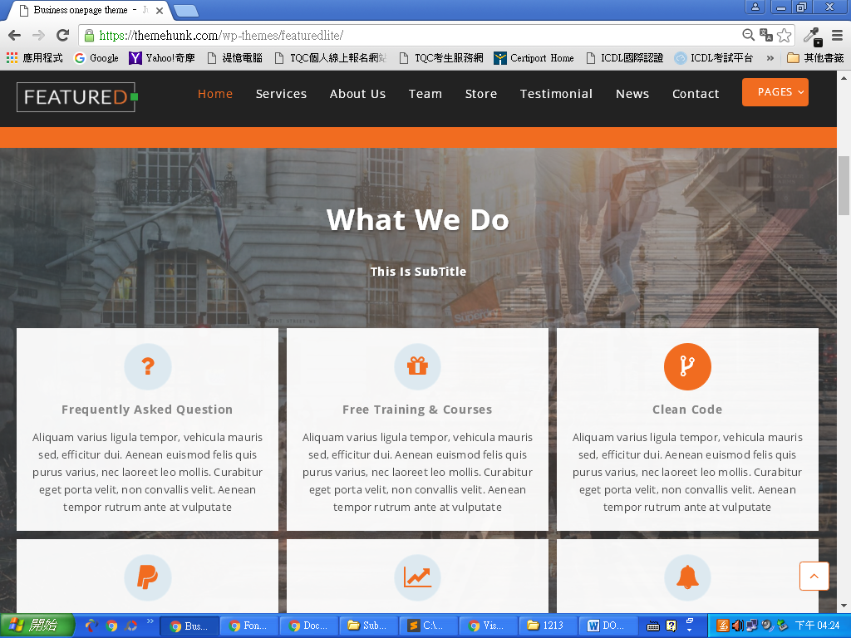

|  |  |
| --- | --- |
|  | <!DOCTYPE html> |
|  | <html lang="en"> |
|  | <head> |
|  | <meta charset="UTF-8"> |
|  | <title>Document</title> |
|  | <link rel="stylesheet" href="<https://cdnjs.cloudflare.com/ajax/libs/font-awesome/4.7.0/css/font-awesome.min.css>"> |
|  | <style> |
|  | @import url('https://fonts.googleapis.com/css?family=Josefin+Sans:300,600'); |
|  | @import url(https://fonts.googleapis.com/earlyaccess/notosanstc.css); |
|  | *{ |
|  | font-family: "Josefin Sans","Noto Sans TC"; |
|  | } |
|  | body,h1,h2,h3,h4,h5,h6,ul,li,p{ |
|  | margin: 0; |
|  | padding: 0; |
|  | } |
|  | .clearfix::after{ |
|  | content: ""; |
|  | display: block; |
|  | clear: both; |
|  | } |
|  | a{ |
|  | text-decoration: none; |
|  | color:#000; |
|  | } |
|  | img{ |
|  | width: 100%; |
|  | } |
|  | .fixed-width{ |
|  | width: 960px; |
|  | margin:auto; |
|  | } |
|  | .full-width{ |
|  | width: 100%; |
|  | } |
|  | .col-2{ |
|  | width: calc(100% / 2 - 30px); |
|  | float: left; |
|  | margin: 0 15px; |
|  | } |
|  | .col-3{ |
|  | width: calc(100% / 3 - 30px); |
|  | float: left; |
|  | margin: 0 15px; |
|  | } |
|  | .col-4{ |
|  | width: calc(100% / 4 - 30px); |
|  | float: left; |
|  | margin: 0 15px; |
|  | } |
|  | nav{ |
|  | background-color: transparent; |
|  | position: fixed; |
|  | z-index: 9; |
|  | } |
|  | nav .logo{ |
|  | float: left; |
|  | height: 40px; |
|  | line-height: 40px; |
|  | color: #fff; |
|  | font-size: 22px; |
|  | border: 3px solid #FFF; |
|  | font-weight: 600; |
|  | margin:12px 0; |
|  | padding: 0 5px; |
|  | } |
|  | nav .orange{ |
|  | color:#c15d1f; |
|  | } |
|  | nav ul{ |
|  | float: right; |
|  | } |
|  | nav li { |
|  | list-style-type: none; |
|  | float: left; |
|  | } |
|  | nav a{ |
|  | display: block; |
|  | height: 70px; |
|  | line-height: 70px; |
|  | color: #fff; |
|  | text-align: center; |
|  | padding-left: 15px; |
|  | } |
|  | header{ |
|  | background-image: url(jorik-blom-366499.jpg); |
|  | background-repeat: no-repeat; |
|  | -webkit-background-size: cover; |
|  | background-size: cover; |
|  | background-position: center; |
|  | padding: 250px 0 500px 0; |
|  |  |
|  | } |
|  | header .title{ |
|  | text-align: center; |
|  | } |
|  | header .title h1{ |
|  | font-size: 36px; |
|  | color:#fff; |
|  | } |
|  | header .title hr{ |
|  | width: 270px; |
|  | height: 1px; |
|  | background-color: #fff; |
|  | } |
|  | header .title h3{ |
|  | color: #fff; |
|  | font-style: italic; |
|  | font-size: 24px; |
|  | } |
|  | header .title a,header .right a{ |
|  | display: block; |
|  | width: 86px; |
|  | height: 25px; |
|  | text-align: center; |
|  | line-height: 25px; |
|  | background-color: rgba(255,255,255,.5); |
|  | padding: 10px 20px; |
|  | margin: auto; |
|  | margin-top: 50px; |
|  | border-radius: 5px; |
|  | transition: all 0.3s; |
|  | } |
|  | header .title a:hover{ |
|  | background-color: #c15d1f; |
|  | } |
|  | header .menu{ |
|  | color: #fff; |
|  | text-align: center; |
|  | margin-top: 50px; |
|  |  |
|  | } |
|  | header .icon{ |
|  | border-radius: 50%; |
|  | border: 1px solid #fff; |
|  | padding: 10px; |
|  | margin-bottom: 15px; |
|  | } |
|  | header .menu .col-3{ |
|  | transition:all 0.3s; |
|  | padding: 15px; |
|  | -webkit-box-sizing: border-box; |
|  | -moz-box-sizing: border-box; |
|  | box-sizing: border-box; |
|  | } |
|  | header .menu .col-3:hover{ |
|  | background-color: rgba(0,0,0,0.5); |
|  | } |
|  | .orangeblock{ |
|  | height: 200px; |
|  | background-color: #c15d1f; |
|  | margin-top: 50px; |
|  | } |
|  | .orangeblock .left{ |
|  | float: left; |
|  | font-size: 24px; |
|  | color:#fff; |
|  | line-height: 200px; |
|  | } |
|  | .orangeblock .right{ |
|  | float: right; |
|  | } |
|  | .orangeblock .right a { |
|  | font-size: 14px; |
|  | margin-top: 77.5px; |
|  |  |
|  | } |
|  | .what{ |
|  | text-align: center; |
|  | } |
|  | .what h2{ |
|  | color: #fff; |
|  | margin: 30px 0 15px 0; |
|  | font-size: 36px; |
|  | } |
|  | .what h4{ |
|  | color: #fff; |
|  | margin: 15px 0 60px 0; |
|  | } |
|  | .what .col-3{ |
|  | background-color: #fff; |
|  | padding: 10px; |
|  | -webkit-box-sizing: border-box; |
|  | -moz-box-sizing: border-box; |
|  | box-sizing: border-box; |
|  | margin-top: 15px; |
|  | margin-bottom: 15px; |
|  | } |
|  | .what .col-3 h5{ |
|  | margin: 5px 0; |
|  | color: rgba(0,0,0,0.8); |
|  | font-size: 18px; |
|  | } |
|  | .what .col-3 p { |
|  | font-size: 12px; |
|  | color: rgba(0,0,0,0.7); |
|  | } |
|  | </style> |
|  | </head> |
|  | <body> |
|  | <!-- nav.full-width>.fixed-width>.logo+ul>li*8>a --> |
|  | <nav class="full-width clearfix"> |
|  | <div class="fixed-width"> |
|  | <div class="logo">FEATURE<span class="orange">D</span></div> |
|  | <ul> |
|  | <li><a href="">Home</a></li> |
|  | <li><a href="">Service</a></li> |
|  | <li><a href="">About Us</a></li> |
|  | <li><a href="">Team</a></li> |
|  | <li><a href="">Store</a></li> |
|  | <li><a href="">Testimonial</a></li> |
|  | <li><a href="">News</a></li> |
|  | <li><a href="">Contact</a></li> |
|  | </ul> |
|  | </div> |
|  | </nav> |
|  | <header class="full-width"> |
|  | <div class="title"> |
|  | <h1>Beautiful WordPress Business Theme</h1> |
|  | <hr> |
|  | <h3>Cleanly Coded With User Friendly Interface</h3> |
|  | <a href="">Buy Now</a> |
|  | </div> |
|  | <div class="menu full-width clearfix"> |
|  | <div class="col-3"> |
|  | <div class="icon fa fa-star fa-2x"></div> |
|  | <h4>Parallax Effect</h4> |
|  | <p>Lorem ipsum dolor sit amet</p> |
|  | </div> |
|  | <div class="col-3"> |
|  | <div class="icon fa fa-thumbs-up fa-2x"></div> |
|  | <h4>Unlimited Options</h4> |
|  | <p>Lorem ipsum dolor sit amet</p> |
|  | </div> |
|  | <div class="col-3"> |
|  | <div class="icon fa fa-sign-language fa-2x"></div> |
|  | <h4>Responsice Design</h4> |
|  | <p>Lorem ipsum dolor sit amet</p> |
|  | </div> |
|  | </div> |
|  | <div class="orangeblock full-width"> |
|  | <div class="fixed-width"> |
|  | <div class="left"> |
|  | Easy to step up, just take a few steps and your website is ready within a minute |
|  | </div> |
|  | <div class="right"> |
|  | <a href="">Call To Action</a> |
|  | </div> |
|  | </div> |
|  | </div> |
|  | <div class="what"> |
|  | <div class="fixed-width"> |
|  | <h2>What We Do</h2> |
|  | <h4>This Is SubTitle</h4> |
|  | <!-- .col-3*6>.icon_what+h5+p{Aliquam varius ligula tempor, vehicula mauris sed, efficitur dui. Aenean euismod felis quis purus varius, nec laoreet leo mollis. Curabitur eget porta velit, non convallis velit. Aenean tempor rutrum ante at vulputate} --> |
|  | <div class="col-3"> |
|  | <div class="icon_what fa fa-medium"></div> |
|  | <h5>Frequently Asked Question</h5> |
|  | <p>Aliquam varius ligula tempor, vehicula mauris sed, efficitur dui. Aenean euismod felis quis purus varius, nec laoreet leo mollis. Curabitur eget porta velit, non convallis velit. Aenean tempor rutrum ante at vulputate</p> |
|  | </div> |
|  | <div class="col-3"> |
|  | <div class="icon_what fa fa-ioxhost"></div> |
|  | <h5>Free Training & Courses</h5> |
|  | <p>Aliquam varius ligula tempor, vehicula mauris sed, efficitur dui. Aenean euismod felis quis purus varius, nec laoreet leo mollis. Curabitur eget porta velit, non convallis velit. Aenean tempor rutrum ante at vulputate</p> |
|  | </div> |
|  | <div class="col-3"> |
|  | <div class="icon_what fa fa-stumbleupon"></div> |
|  | <h5>Clean Code</h5> |
|  | <p>Aliquam varius ligula tempor, vehicula mauris sed, efficitur dui. Aenean euismod felis quis purus varius, nec laoreet leo mollis. Curabitur eget porta velit, non convallis velit. Aenean tempor rutrum ante at vulputate</p> |
|  | </div> |
|  | <div class="col-3"> |
|  | <div class="icon_what fa fa-hospital-o"></div> |
|  | <h5>Only Good In PayPal</h5> |
|  | <p>Aliquam varius ligula tempor, vehicula mauris sed, efficitur dui. Aenean euismod felis quis purus varius, nec laoreet leo mollis. Curabitur eget porta velit, non convallis velit. Aenean tempor rutrum ante at vulputate</p> |
|  | </div> |
|  | <div class="col-3"> |
|  | <div class="icon_what fa fa-openid"></div> |
|  | <h5>Production Graph</h5> |
|  | <p>Aliquam varius ligula tempor, vehicula mauris sed, efficitur dui. Aenean euismod felis quis purus varius, nec laoreet leo mollis. Curabitur eget porta velit, non convallis velit. Aenean tempor rutrum ante at vulputate</p> |
|  | </div> |
|  | <div class="col-3"> |
|  | <div class="icon_what fa fa-wheelchair-alt"></div> |
|  | <h5>Marketing Strategy</h5> |
|  | <p>Aliquam varius ligula tempor, vehicula mauris sed, efficitur dui. Aenean euismod felis quis purus varius, nec laoreet leo mollis. Curabitur eget porta velit, non convallis velit. Aenean tempor rutrum ante at vulputate</p> |
|  | </div> |
|  | </div> |
|  | </div> |
|  | </header> |
|  | </body> |
|  | </html> |

<https://themehunk.com/wp-themes/featuredlite/>

